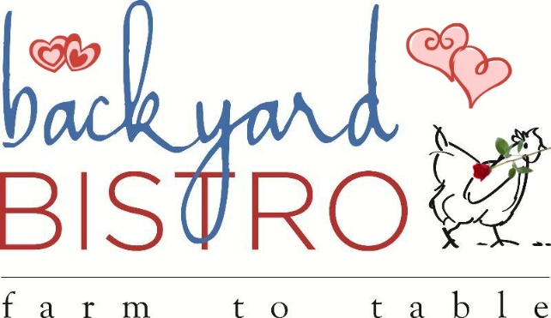
Red Infused
Valentine’s Menu

All entrees are served with House Salad topped with Strawberry Tarragon Vinaigrette

Starters
Shrimp Corn Dogs with Mango Thai Chili Sauce $10
Crab Cake with Roasted Red Pepper Remoulade $14
Entrees
22oz Heart Shaped Rib-eye for 2 with Mashed Potatoes & Asparagus $60
Surf & Turf- 8oz Bison New York Strip Steak with Seared Sea Scallops Mashed Potatoes & Asparagus $50
California Cioppino- Salmon, Shrimp, Atlantic Cod & Mussels poached in a White Wine Seafood Tomato & Roasted Red Pepper Broth $35
Rainbow Trout served with Mashed Potatoes & Asparagus $22
Roasted Portobello Mushroom topped with Vegetables & Parmesan served over Roasted Red Pepper Sauce $16
Beef Bourguignon- Beef Tenderloin braised in Red Wine with Bacon, Tomatoes, Mushrooms & Pearl Onions topped with Mashed Potatoes $24
Red Bird Pecan Chicken Breast with Texas Wildflower Honey, on a bed of Pasta, Fresh Spinach, Tomatoes & Lemon Butter Sauce $18
Baked Salmon Wrapped in Phyllo with Spinach Mousse served with Vegetable Au Gratin $24

Red Velvet Cake $5

